Scituate Garden Club -- 2025 Bulb  
Ice King Daffodil

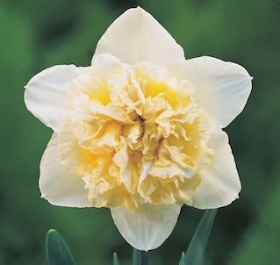

Ice King Daffodil is a double form of Ice Follies. One of the softer shades, it has white petals with a softer yellow frilly center with white highlights.

* Height is 16-18"
* Sweetly fragrant
* Deer & rabbit resistant
* Blooms mid-spring
* Can be forced indoors
* Naturalizes

*A real ‘showoff’ in the landscape!*

Please print and complete the order form below and

Pay at Plant Sale OR

Mail with a check to   
**Scituate Garden Club –BULBS,** P.O. Box 53, Scituate MA 02066

NAME: _____________________________________________________ ADDRESS: ___________________________________________________   
PHONE #:_____________________ EMAIL: ______________________

Number of bags of 25 bulbs _______   
Total bags _____@ $20 = _______